Web Development Project

**Web Profile Application**

By: Sania Bibi

Roll No: BSCS-2019-67

**Introduction**

In this project we are trying to make web application profile in which we have different activities such as login page, register page. The user can register in which we have asked different questions such as name, password, mail etc. and after that he/she can login just by entering name and password and after that he/she can view his profile and update it if he wants and at the end he can logout his profile.

**Problem statement**

The problem is that how can user create and update his profile.

**Purpose statement**

The purpose of this project is to facilitate the user that they can create their profile, view it, update it and log out it.

**Technologies**

Flask framework and MySQL workbench.

**Methodology**

For backend we use MySQL workbench.

**Database of project**

Here we use MySQL database for our project. When user enters his/her details it will store in the database. When we update our profile the data will also updates in database.

For frontend we are going to use flask as a framework although there are other frameworks such as Tornado, Django, etc.

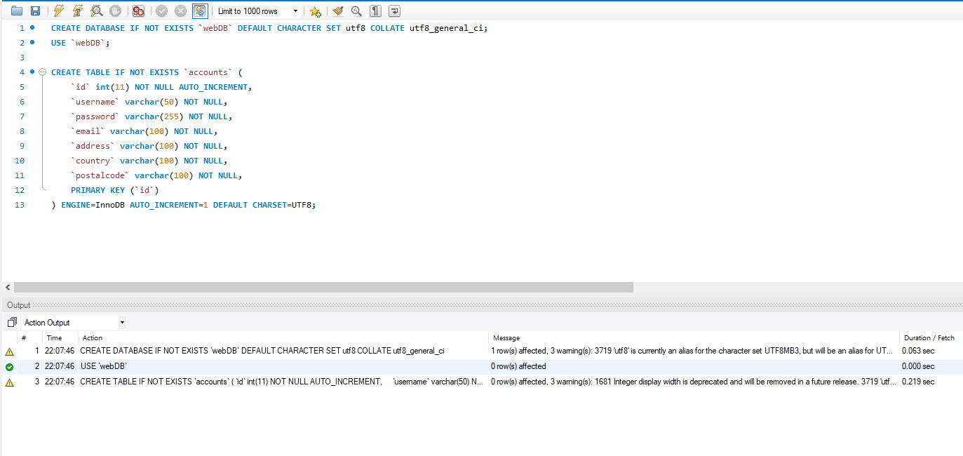

Figure 1 : Database of the project

**Results**

* **Login page**

Here user can login by entering his name and password id he is registered already.

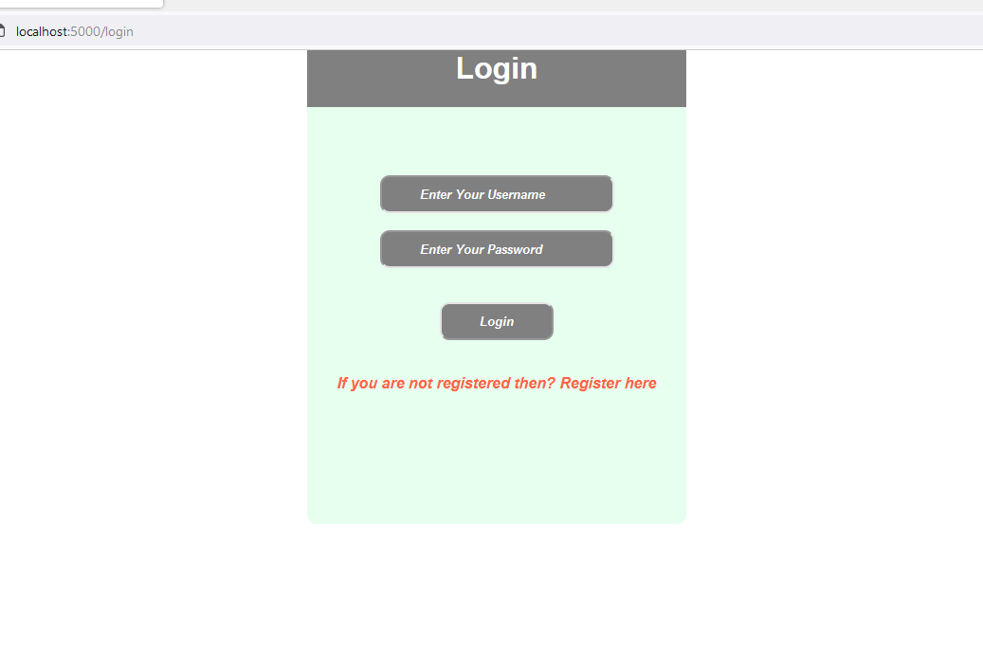

Figure 2 : Here is the Login page

* **Register page**

If user is not registered then by filling all the details given below he can registered.

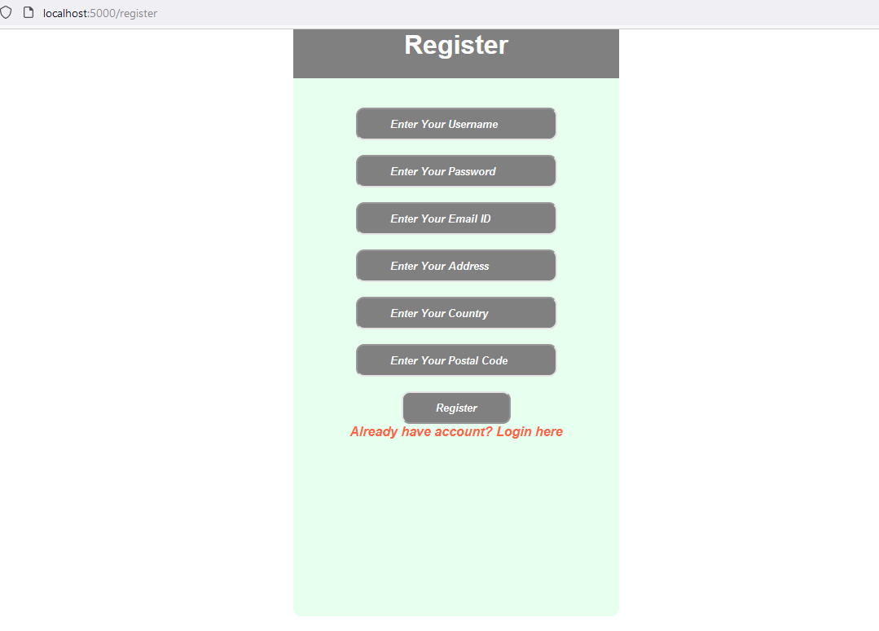

Figure 3: Registration page

* **Index page**

After login we will reach to index page where we have many other options to view the profile and so many others.

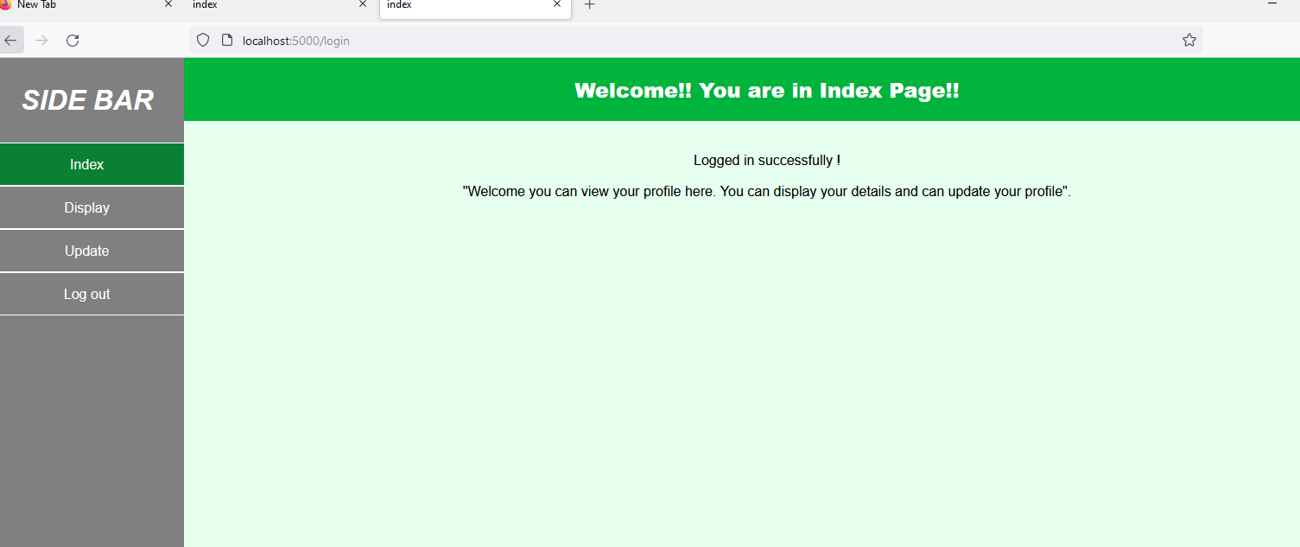

Figure 4: Index page

* **Display page**

On display page we can view our details by clicking on display at sidebar.

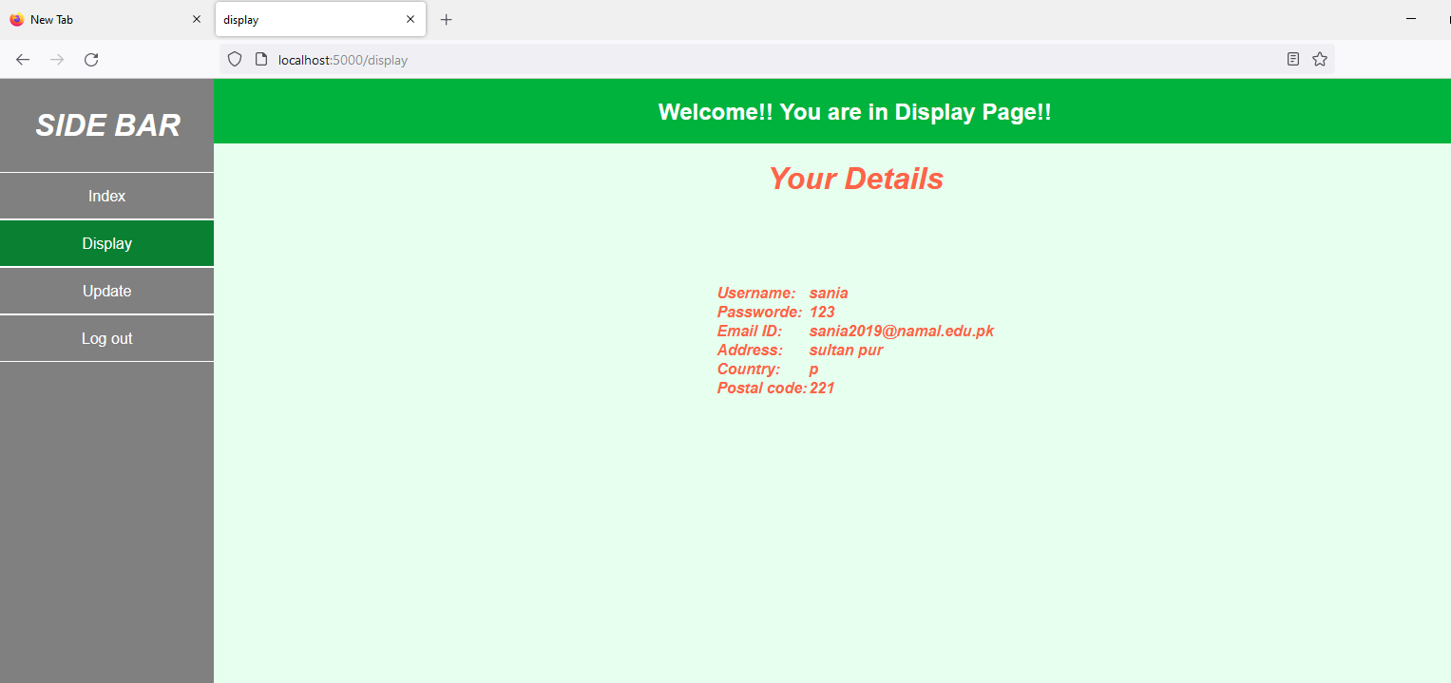

Figure 5: Display page, here we can view our details.

* **Update page**

At this page user can update his profile if he wants. He/she has to enter the new details again in this page.

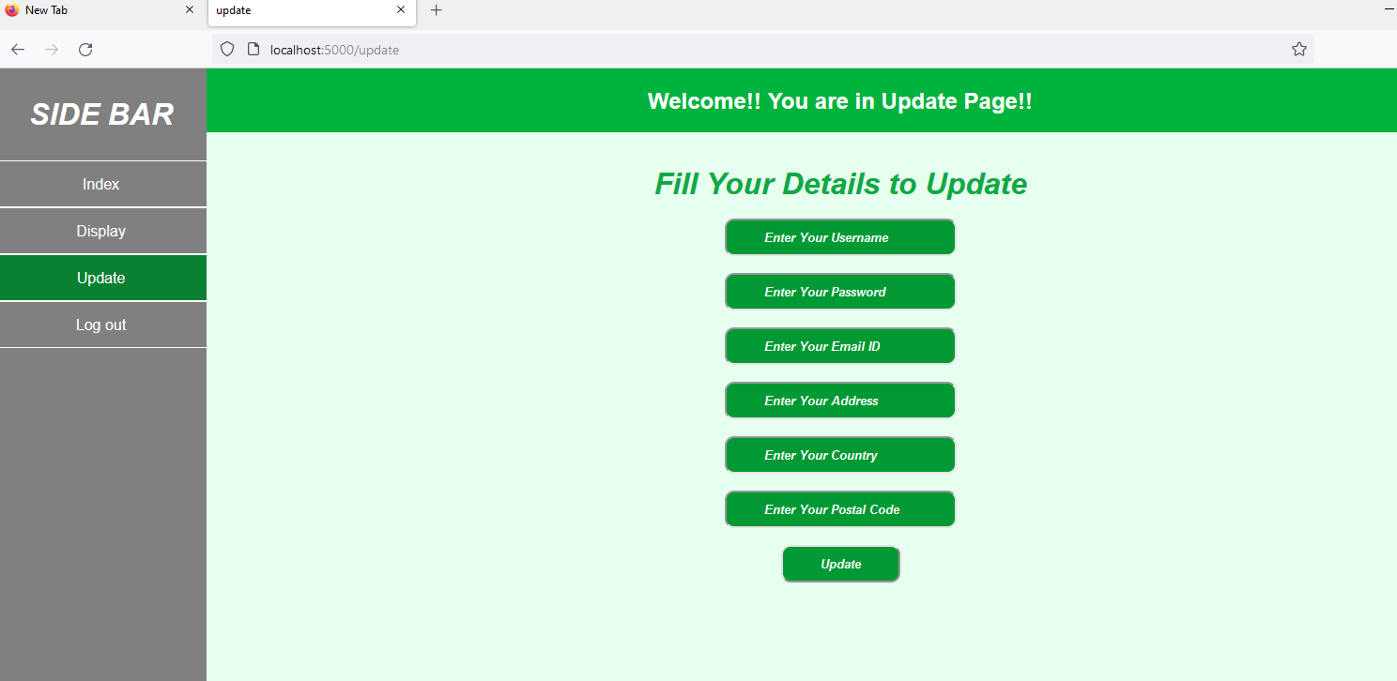

Figure 6: Update page, we can update our profile here.

* **Conclusion**

So at last, when we click on logout our profile will logout and it will redirect us to login page again. So here we can easily deal with our profile and we make it more attractive and interactive by adding some features.

**END**